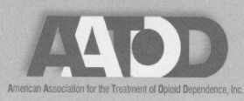

RICHARD LANE/ROBERT HOLDEN PATIENT ADVOCACY AWARD
NOMINATION FORM
Nominee: _______________________________________
DEADLINE: Friday, February 26, 2016 Midnight

Checklist
Completed Nomination Form
Two Letters of Support, which describe the achievements of the nominee
1. ____________________________________
2. ____________________________________
NOTES:
Richard Lane/Robert Holden Patient Advocacy Award
Nomination Form

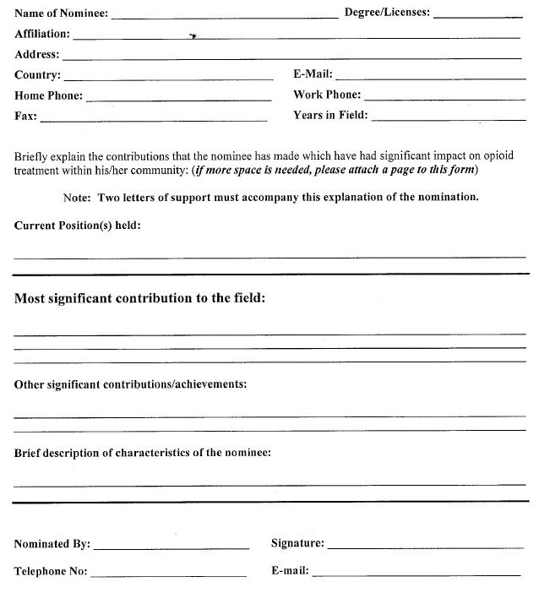
Please mail to: edirector@methadone.org
DEADLINE: Friday, Midnight, February 26, 2016

Suggestions for Persons Nominating an Advocate
- Start by contacting the person you want to nominate and tell them of your intentions. (not everyone may want to be nominated for an award)
- Ask the proposed awardee for their CV or Resume and use this to complete the Nomination Form.
- Ask the proposed awardee to suggest 2 persons that could write Letters of Support.
- Send a copy of the Nomination Criteria to each person that will write a letter of support.
- Remind the 2 writers of the Letters of Support that their letter needs to discuss the accomplishments of the nominee. Remind them to send you the letters before the deadline.
- Send the completed Nomination Form to the proposed awardee and ask them to review it to make sure you have everything listed. (You do not need to send the Letters of Support and in fact the writers may not want the nominee to read their letter.)
- Submit the Forms Including: Nomination Form, 2 Letters of Support by Friday, Midnight, February 26, 2016.
- If you have any questions about the award contact Joycelyn Woods at edirector@methadone.org or by telephone at 917-846-9983

